The Torres Martinez Desert Cahuilla INDIANS Welcome Community Input on tribal Hazard Mitigation Plan update
Join Us in Building a Resilient Future for the Torres Martinez Desert Cahuilla Indians!

WHAT?
Review and provide feedback on the Tribal Hazard Mitigation Plan Update.

HOW?
- For Online Access: https://torresmartinez.org/ to read the draft plan.
- In-Person Viewing: Hard copies available at the Tribal Administration Office.
- Complete the Google Form on the Tribe’s website or at designated locations to provide feedback (link here: https://forms.gle/pTLAfCacLJBiquRu8).

WHEN?
- Commentary Period: January 13, 2025 – January 27, 2025

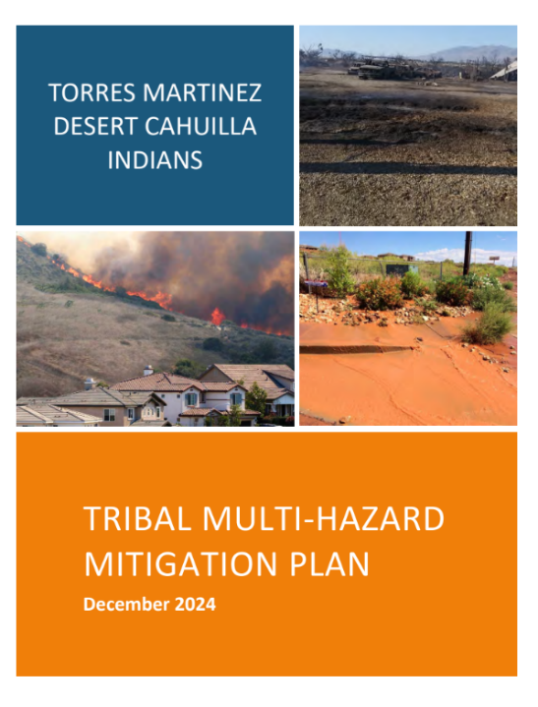
WHY?
- Strengthen your community’s resilience to natural hazards and climate change impacts, such as flooding, high winds, and extreme temperatures.

CONTACT FOR INQUIRIES
- Angel I. Ortega, Emergency Response Manager
- Phone: 760-397-0300 x12016
- Email: aiortega@tmdci-nsn.gov

