

Inforznational Meeting

During this nneeting, we will be going



over everything that is required in the

TYEP Application along with rules and expectations for TVEP workers. 

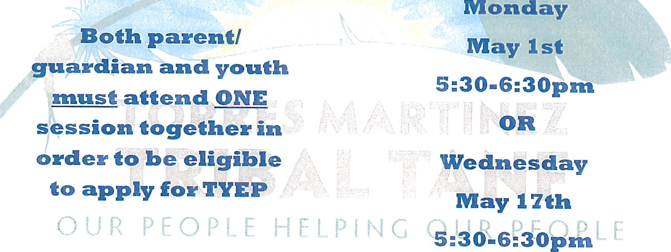

Please contact Mika Tortez at 951=7652 9466 exta IZ05Z or nntortez@tnntanfnorg t